**Task -day20:**

set up a VPC with an Internet gateway, create a public subnet, a private subnet, make a route table connecting the Internet gateway and the subnets, and launch a Linux EC2 instance by using the above VPC and public subnet.

A virtual private cloud (VPC) is a virtual network dedicated to our AWS account. It is logically isolated from other virtual networks in the AWS Cloud. We can specify an IP address range for the VPC, add subnets, add gateways, and associate security groups.

Creating Virtual Private Cloud with CIDR range 180.0.0.0/16 successfully created.

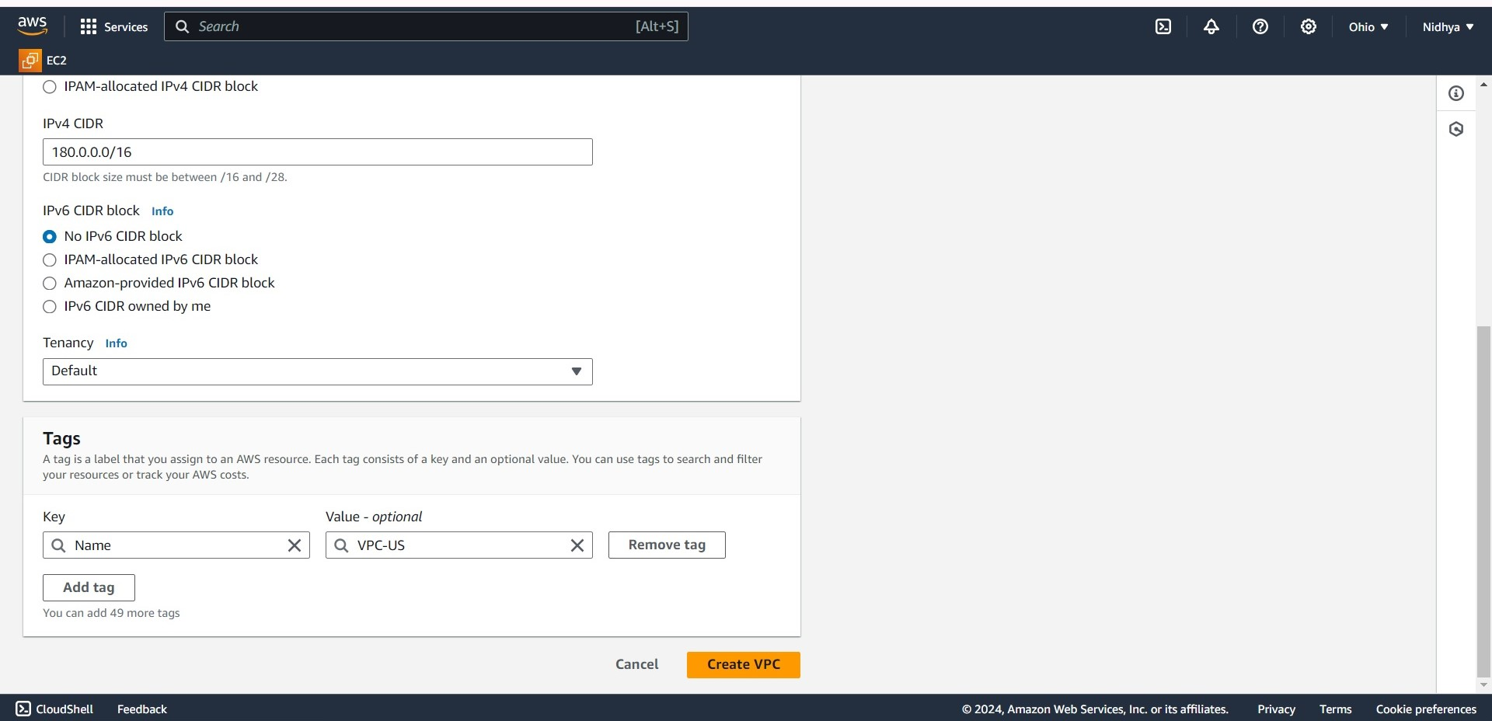

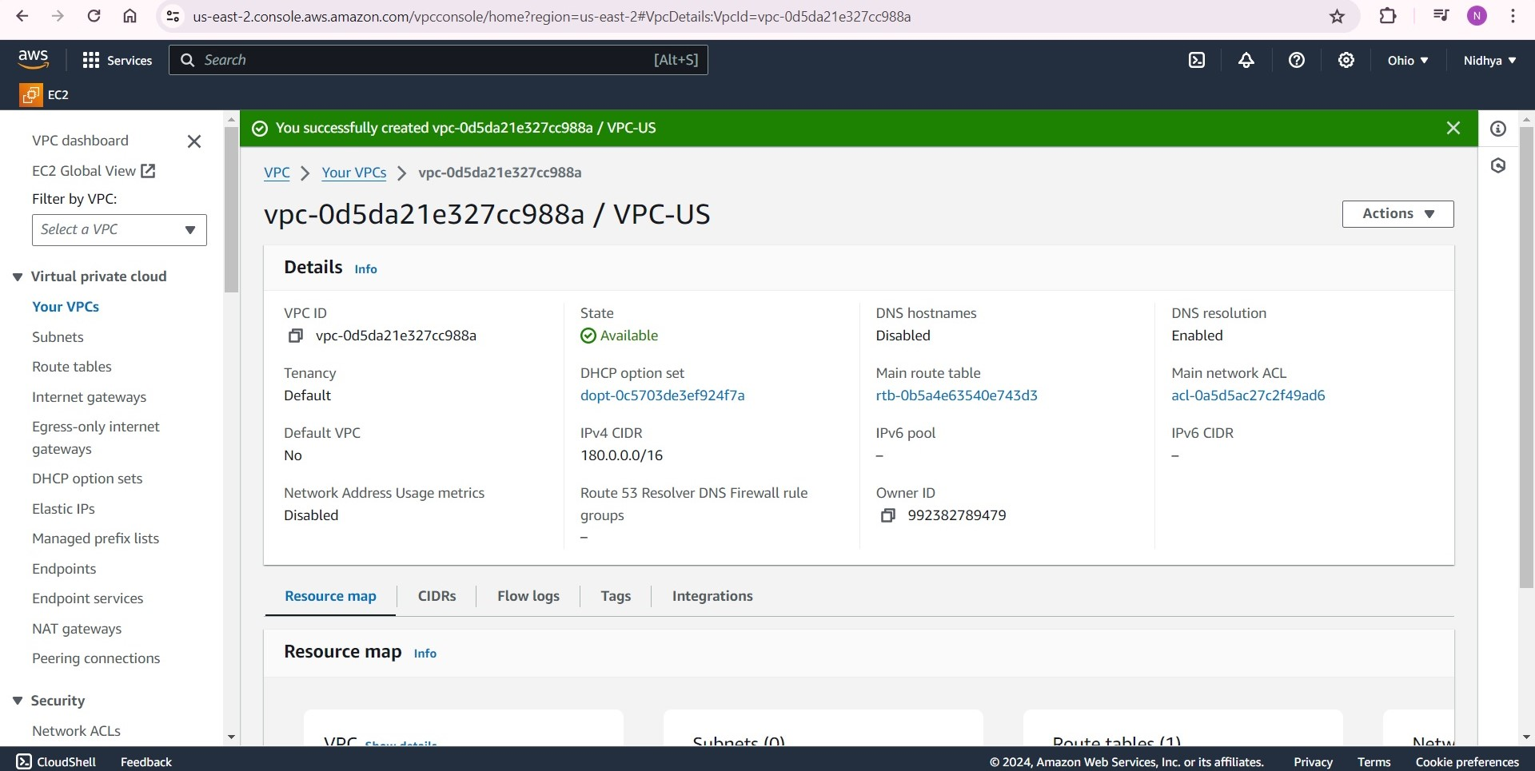

Creating public and private subnets,

A subnet is a range of IP addresses in our VPC. We can create AWS resources, such as EC2 instances, in specific subnets.

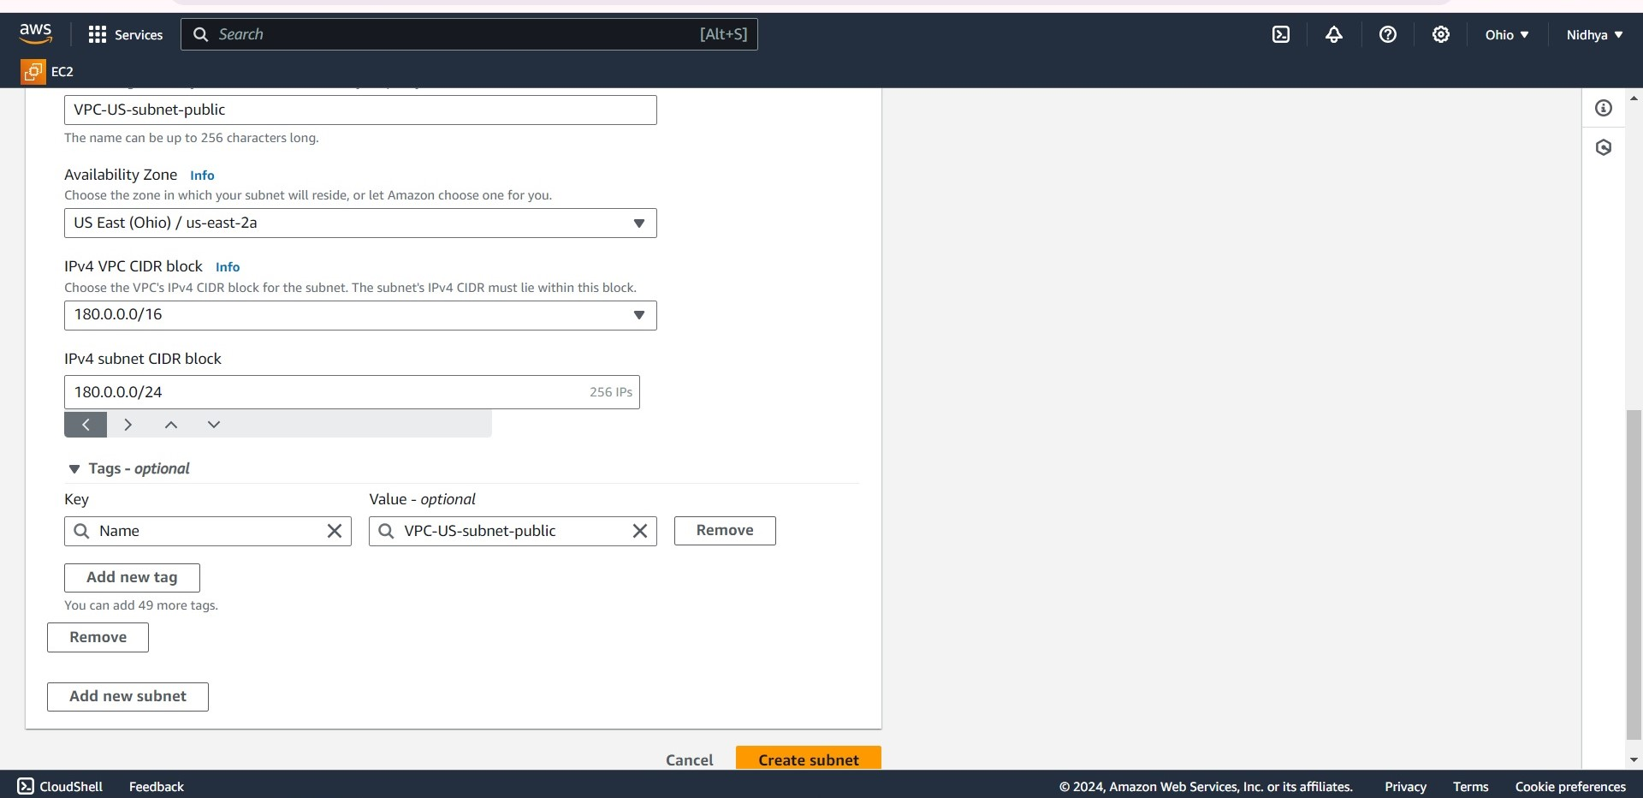

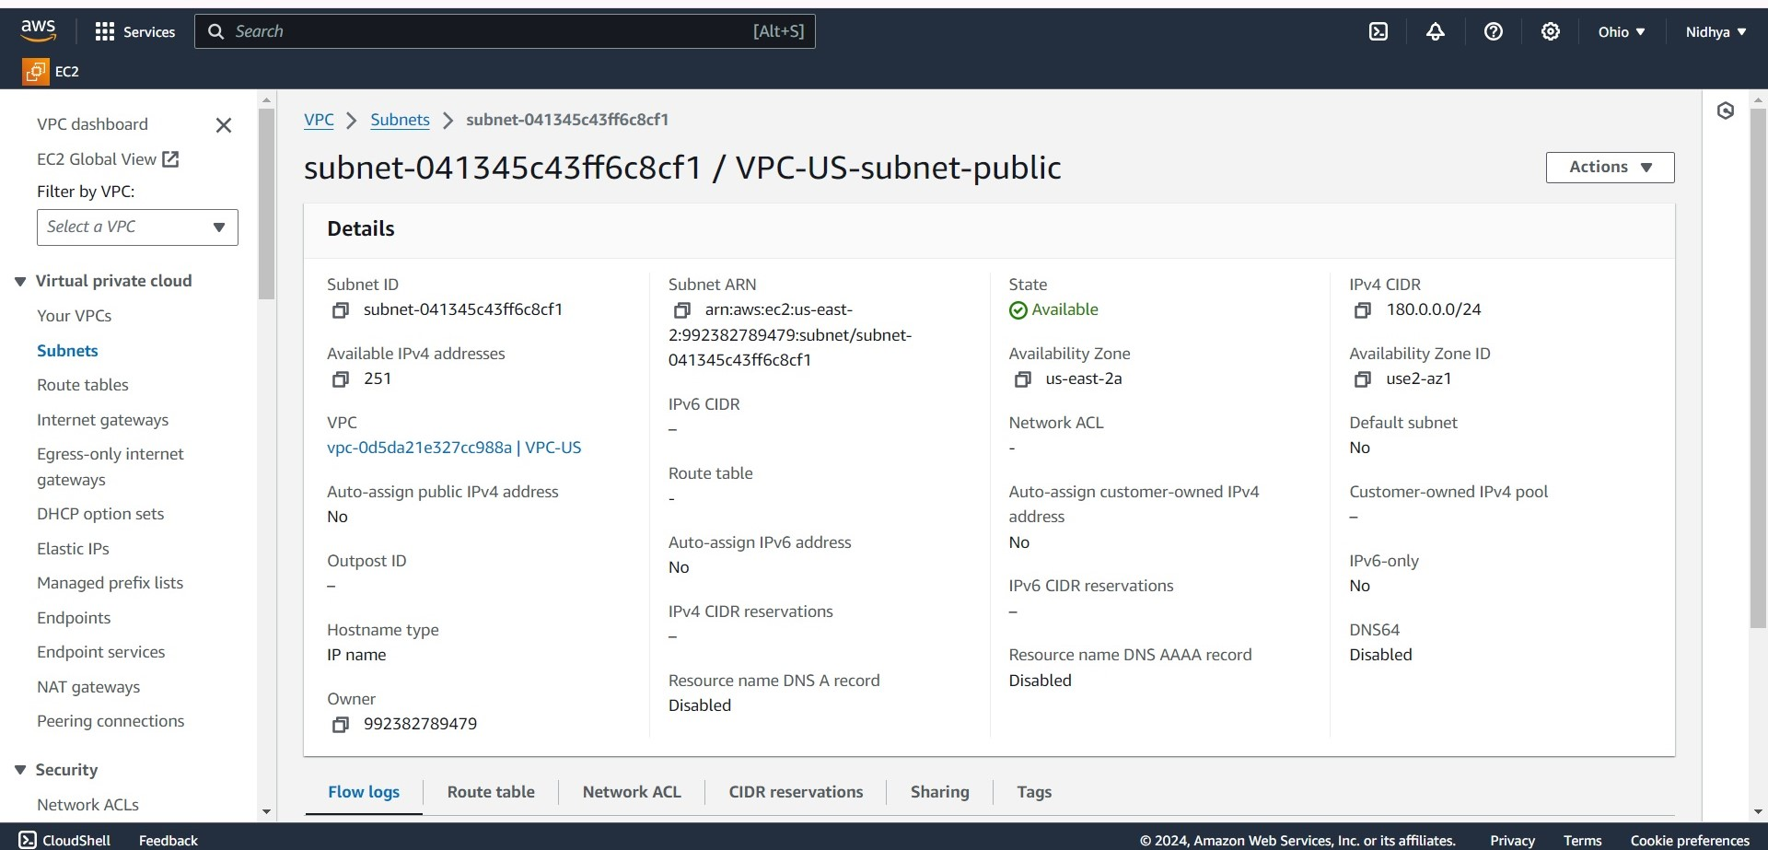

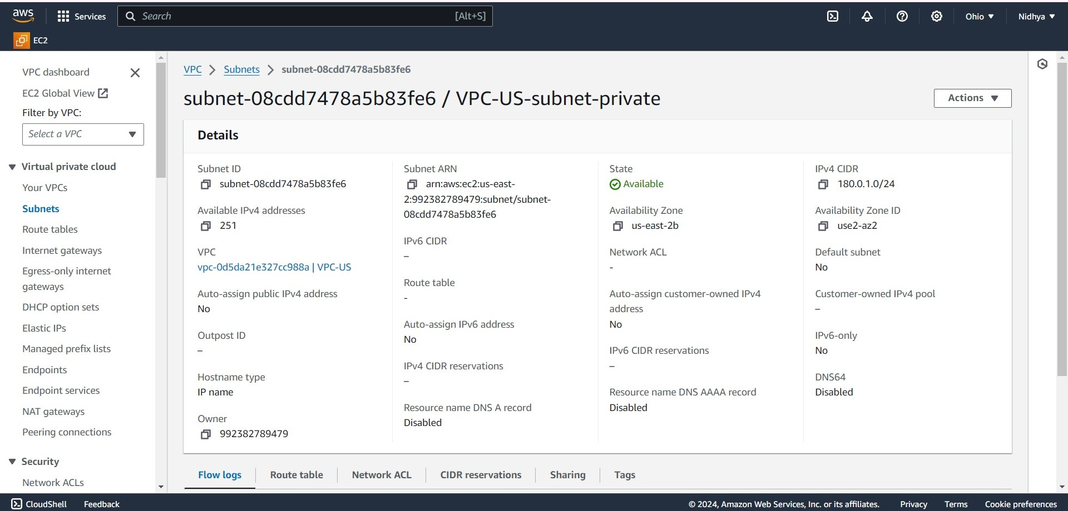

Creating Internet Gateway,

An internet gateway is a horizontally scaled, redundant, and highly available VPC component that allows communication between our VPC and the internet.

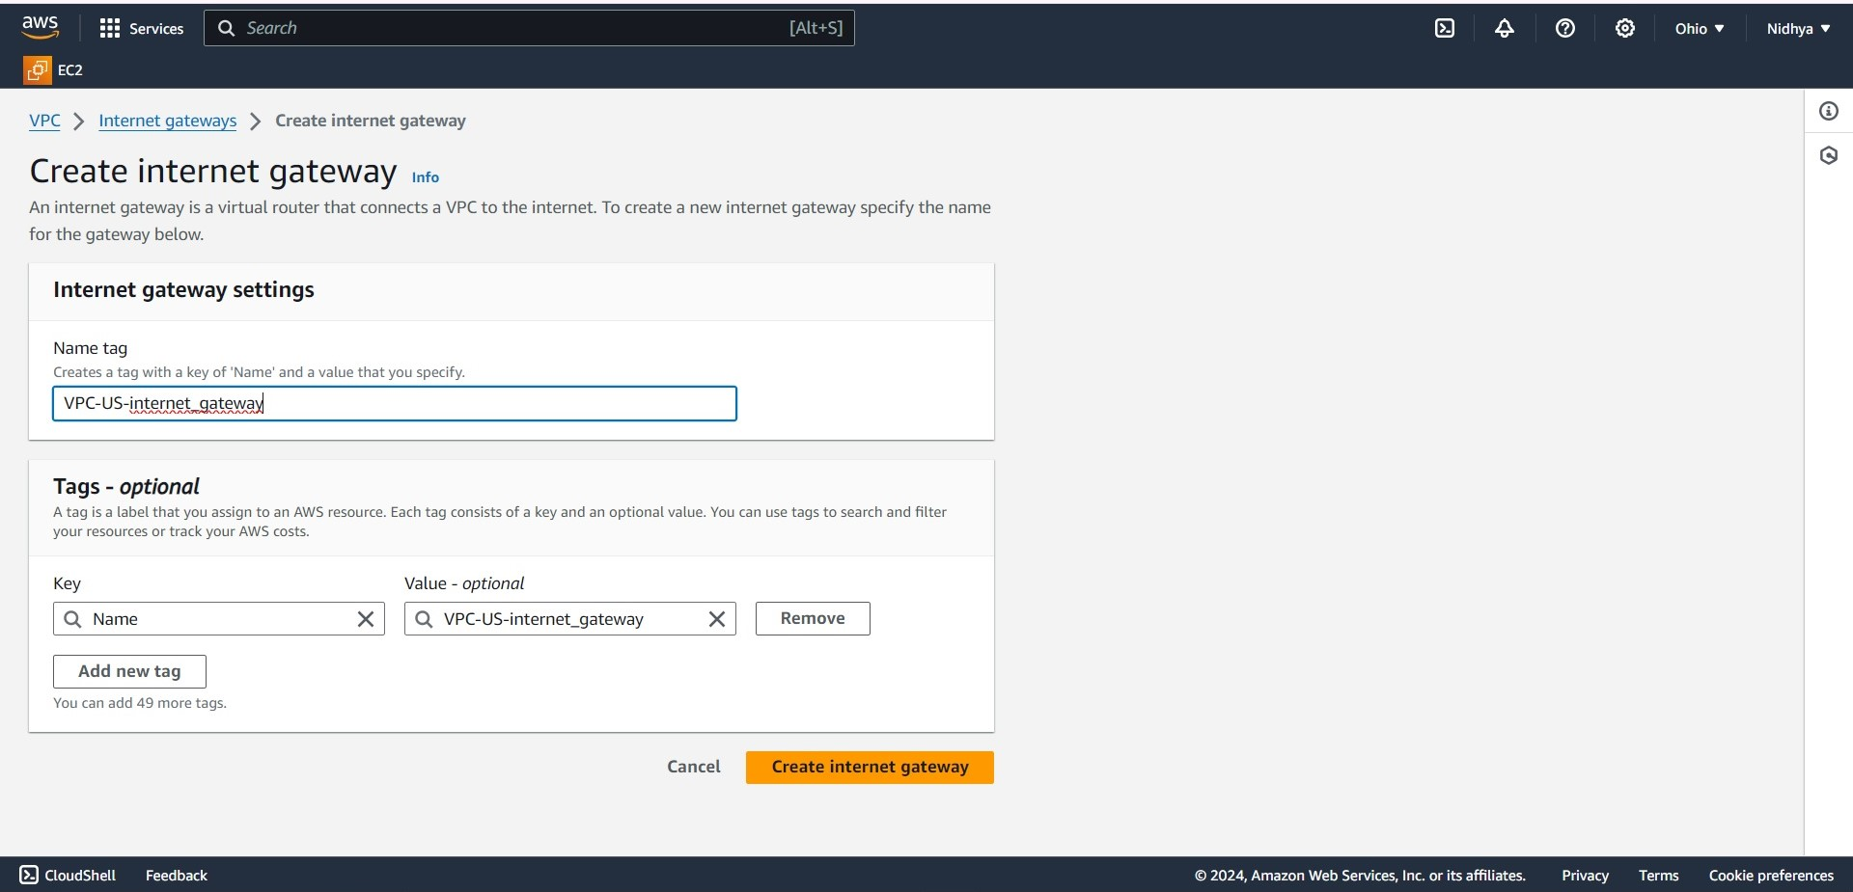

Attach VPC to Internet gateway,

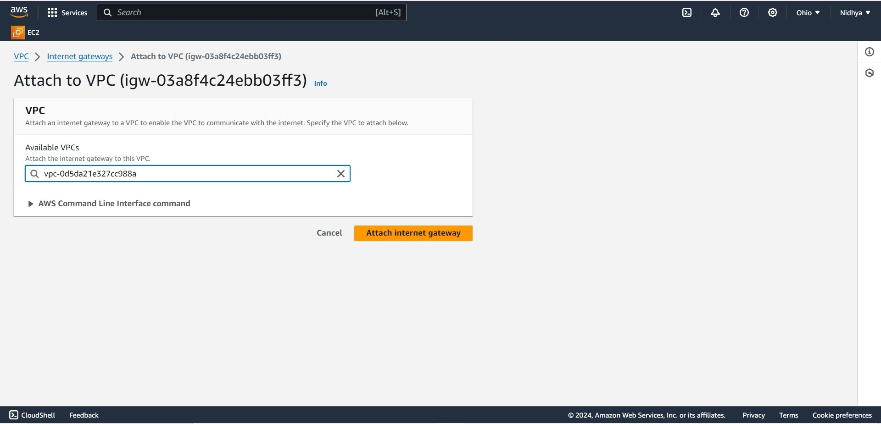

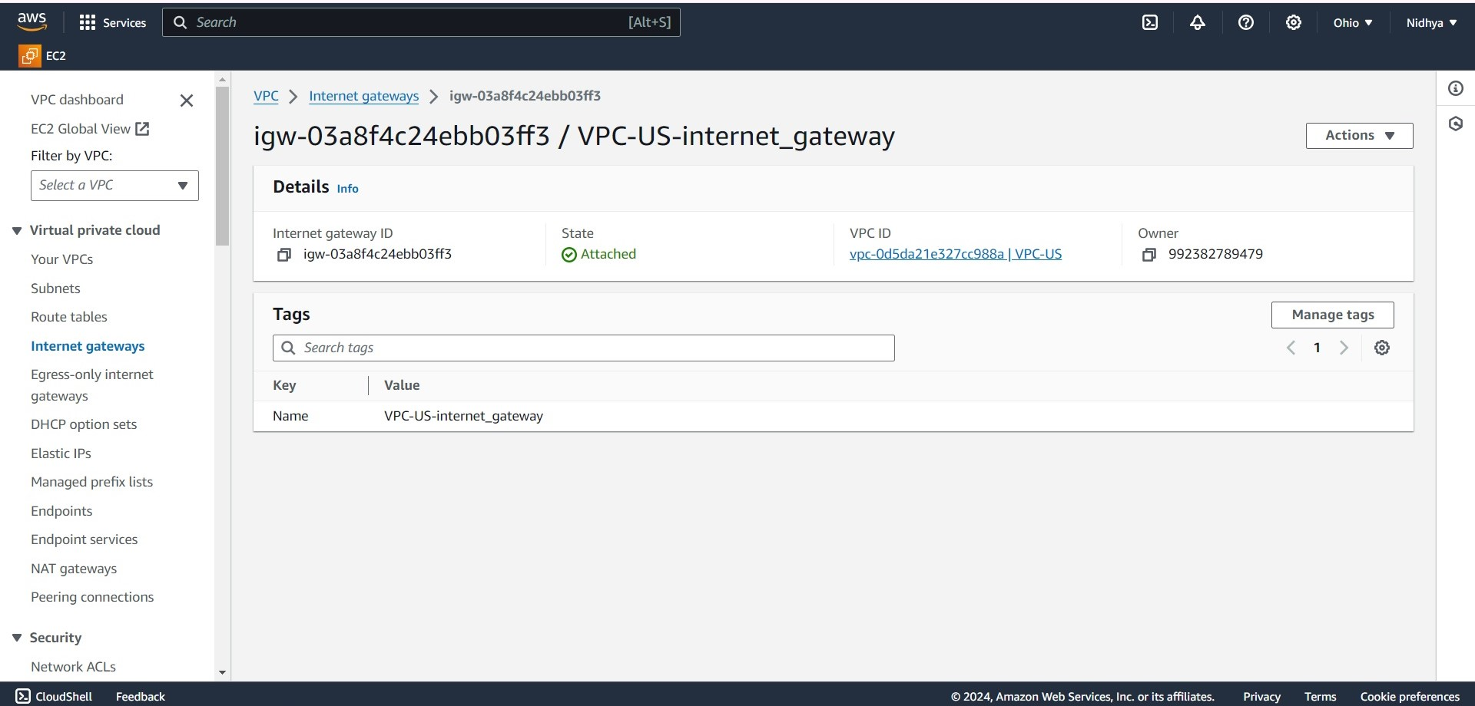

Creating public and private route table,

A route table contains a set of rules, called routes, that determine where network traffic from our subnet or gateway is directed.

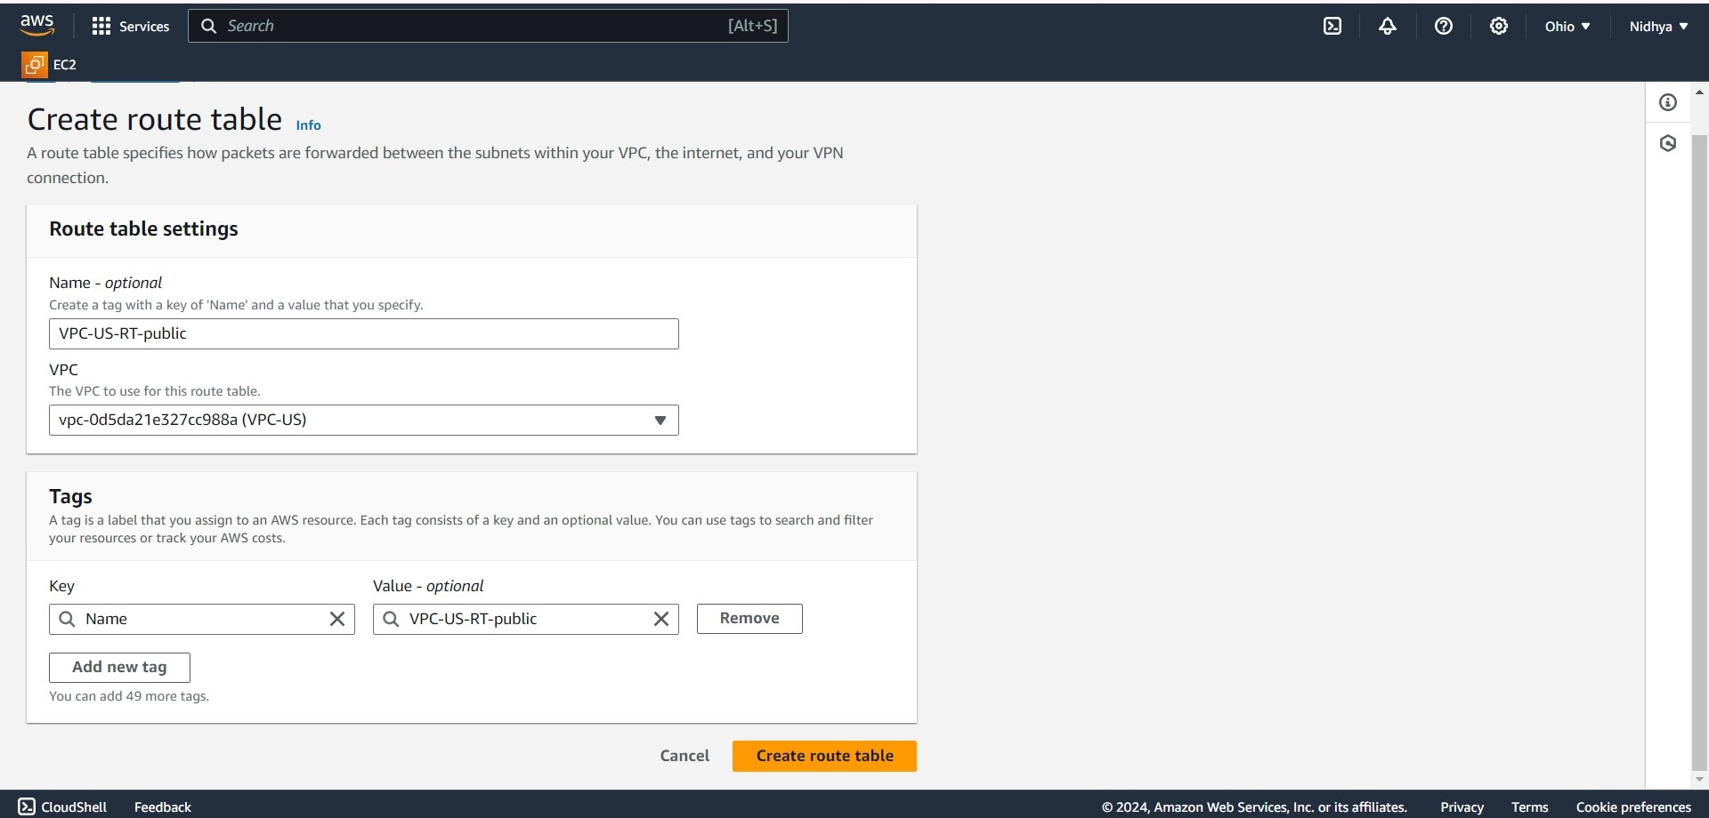

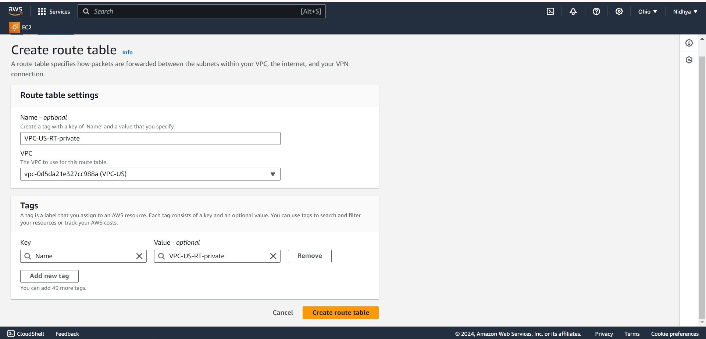

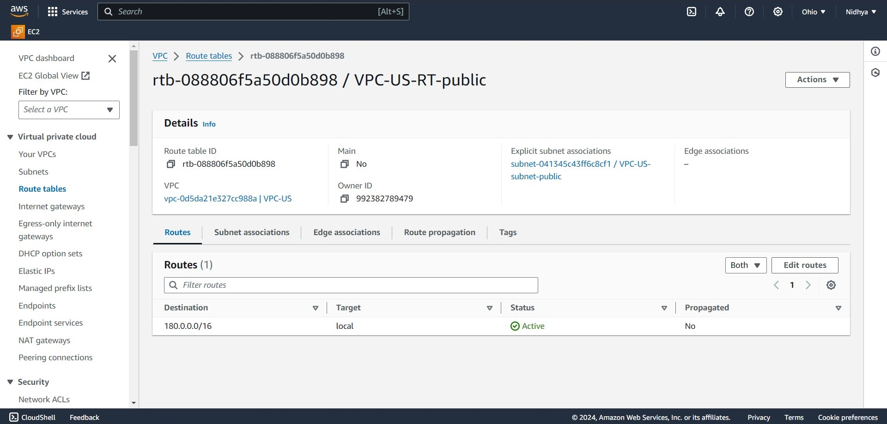

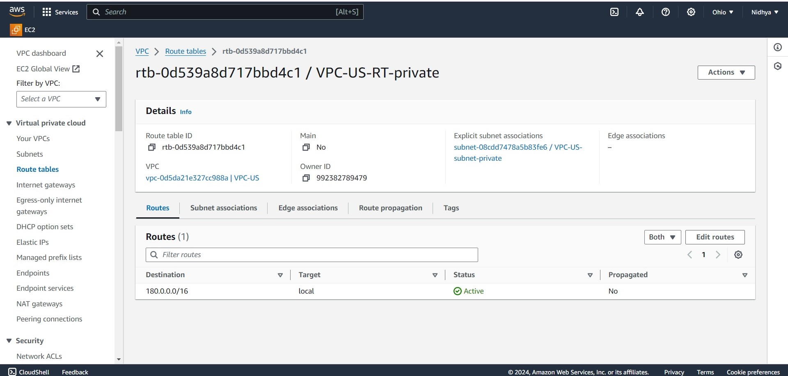

Creating subnet association with Internet gateway through route tables,

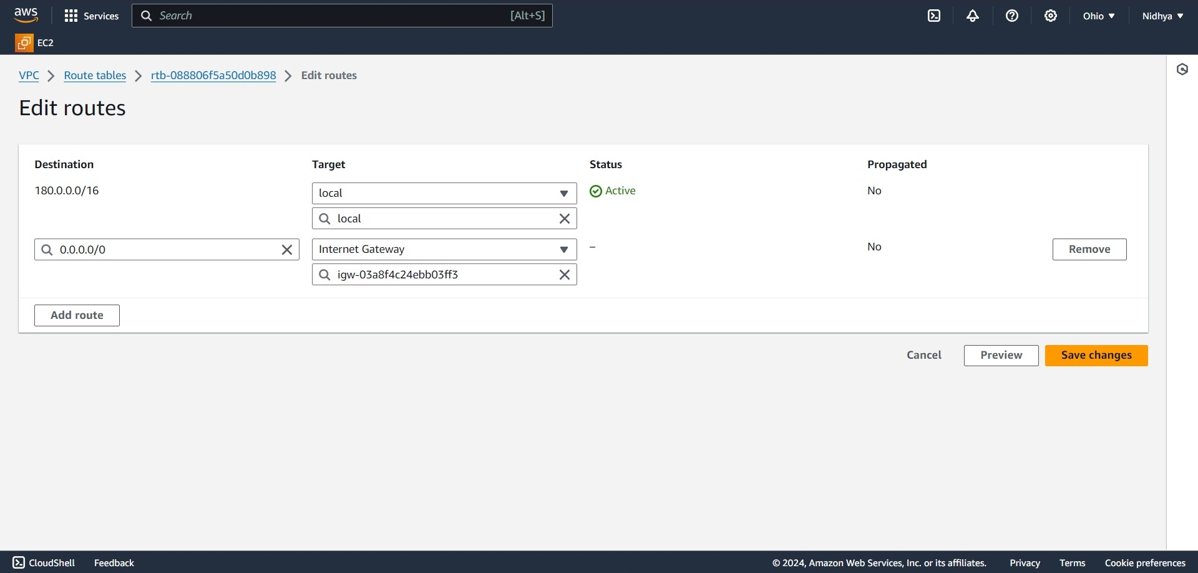

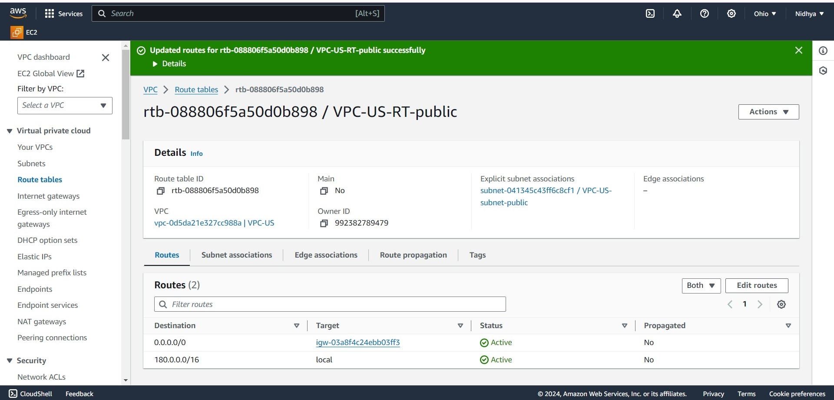

Launching instance within VPC , public subnet with private IP address 180.0.0.163 by auto-assigning Public Elastic IP address - 3.144.115.84,

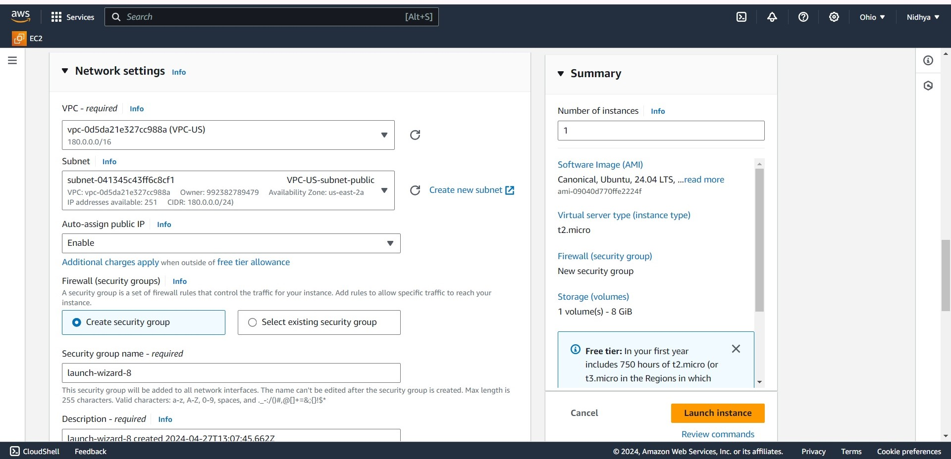

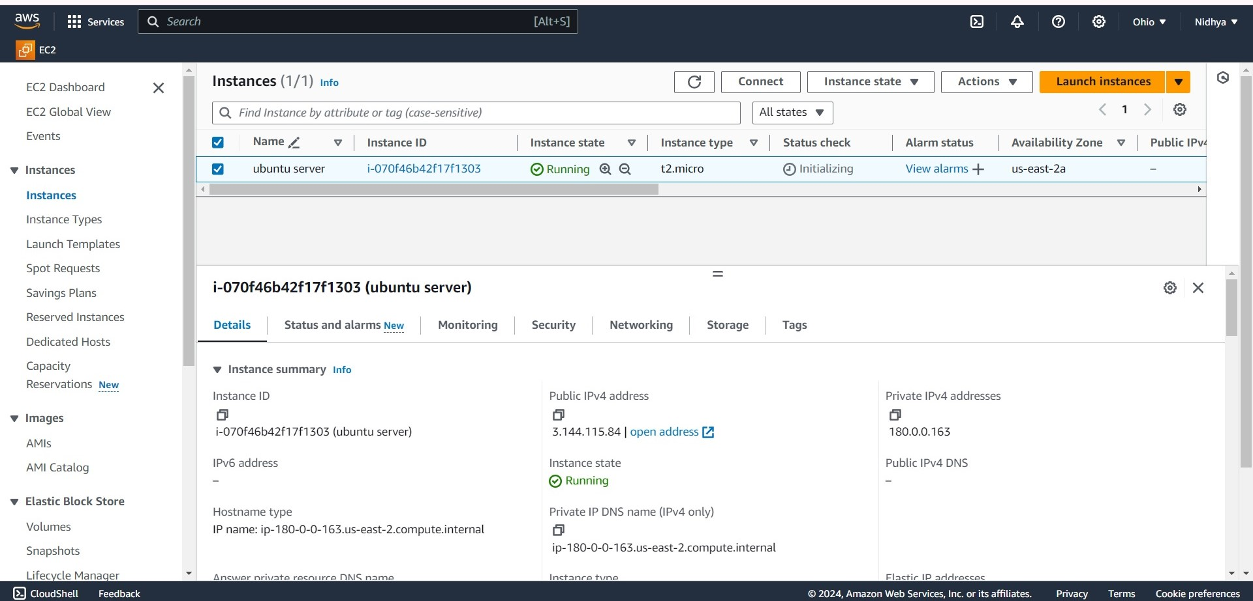

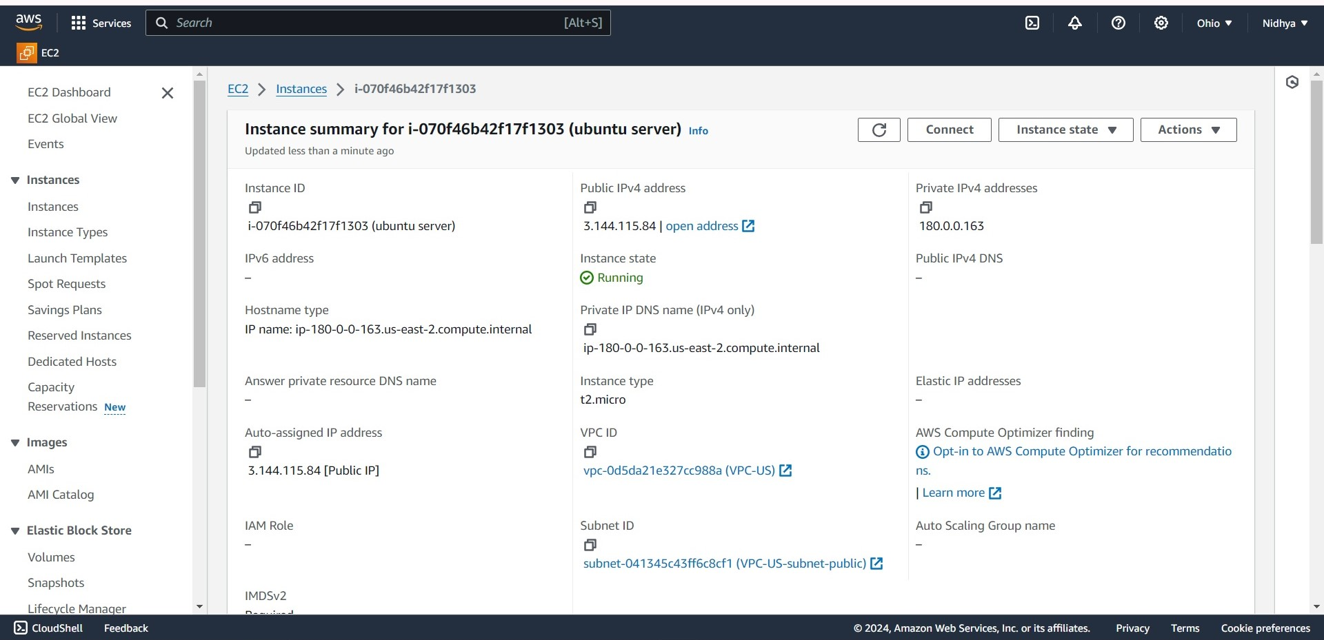

The Ubuntu server is running successfully within VPC with the private IP address 180.0.0.163.

**—---------------------------------------------------------------------------------------------**

**Task -day19:**

Launch an EC2 instance -Linux along with a web server. Then, create an EBS volume of 5 GB, attach it to an EC2 machine Linus, and take a snapshot. Finally, create an EBS volume using the taken snapshot.

Amazon Elastic Block Store (Amazon EBS) provides scalable, high-performance block storage resources that can be used with Amazon Elastic Compute Cloud (Amazon EC2) instances. With Amazon Elastic Block Store, we can create and manage the following block storage resources:

· Amazon EBS volumes — These are storage volumes that we attach to Amazon EC2 instances. After we attach a volume to an instance, we can use it in the same way we would use a local hard drive attached to a computer, for example to store files or to install applications.

· Amazon EBS snapshots — These are point-in-time backups of Amazon EBS volumes that persist independently from the volume itself. We can create snapshots to back up the data on your Amazon EBS volumes. We can then restore new volumes from those snapshots at any time.

Steps to create EBS-Volume:

1. Choose Create volume.

2. For Volume type, choose the type of volume to create. General Purpose SSD gp3 is the default selection.

3. For Size, enter the size of the volume, in 5 GB.

4. For IOPS, enter the maximum number of input/output operations per second (IOPS) that the volume should provide.

5. For Throughput, enter the throughput that the volume should provide, in MB/s.

6. For Availability Zone, choose the Availability Zone in which to create the volume. A volume can be attached only to an instance that is in the same Availability Zone.

7. For Snapshot ID, keep the default value

8. Set the encryption status for the volume.

9. For Snapshot ID, select the snapshot from which to create the volume.

10. For creating volumes from snapshot, create new volumes from those snapshots at any time.

Apache Webserver running on Remote Linux machine:

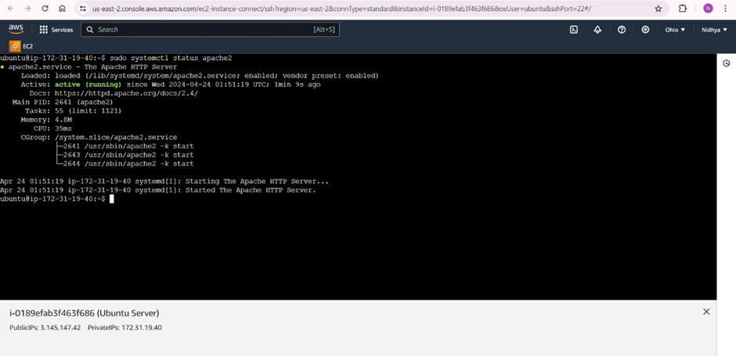

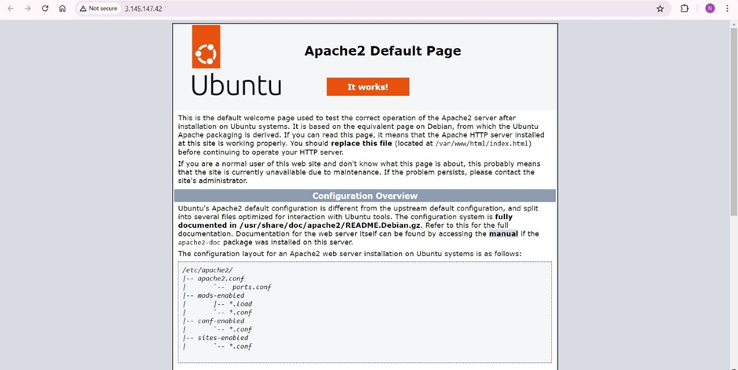

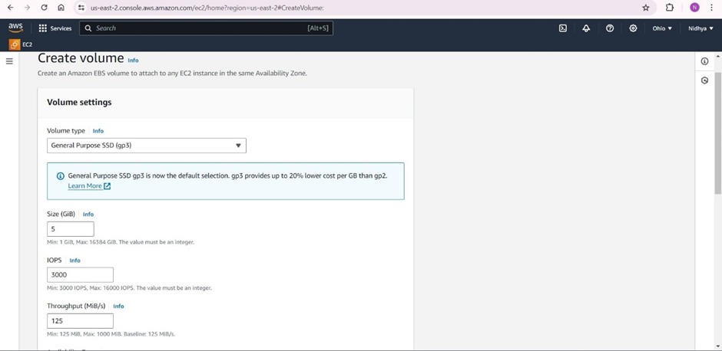

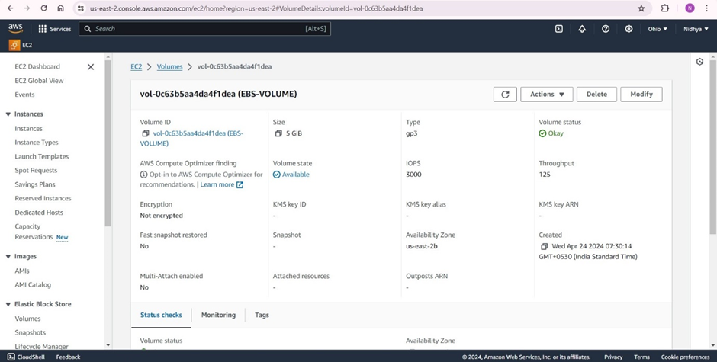

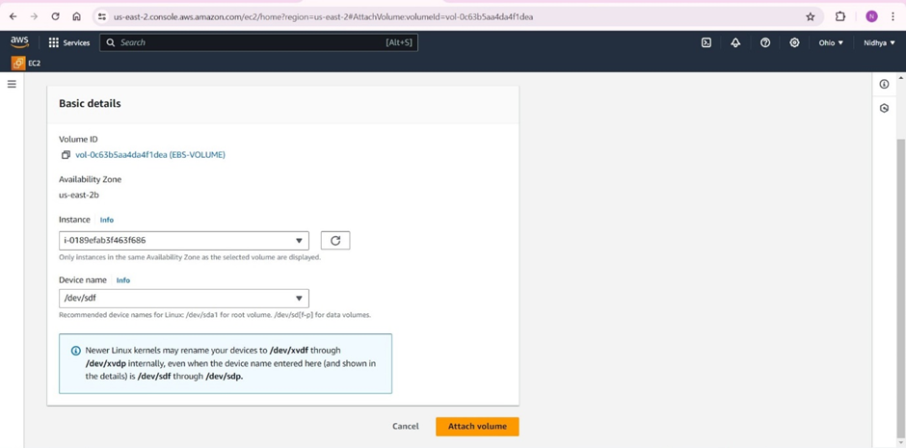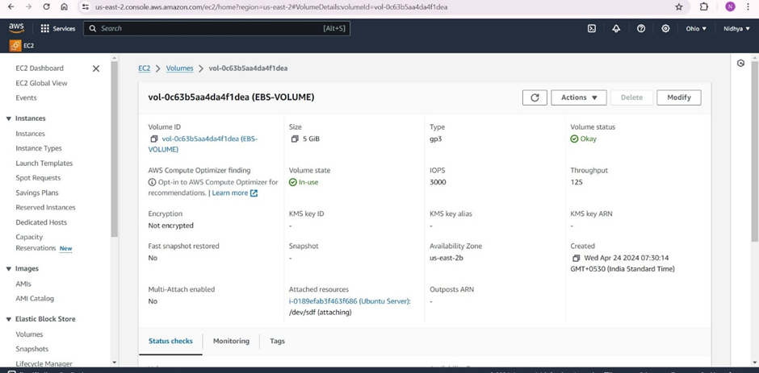

Now we have to mount the file system on your EC2 instance.

The 'lsblk' stands for 'list block devices', and as the name suggests, it is used to list out all block devices in a tree-like format.

This powerful command can help us gather comprehensive information about each block device connected to our Linux system, including the disk partitions and their respective sizes.

In Linux, fstab is part of the util-linux package. The fstab file typically lists all available disk partitions and other types of file systems.

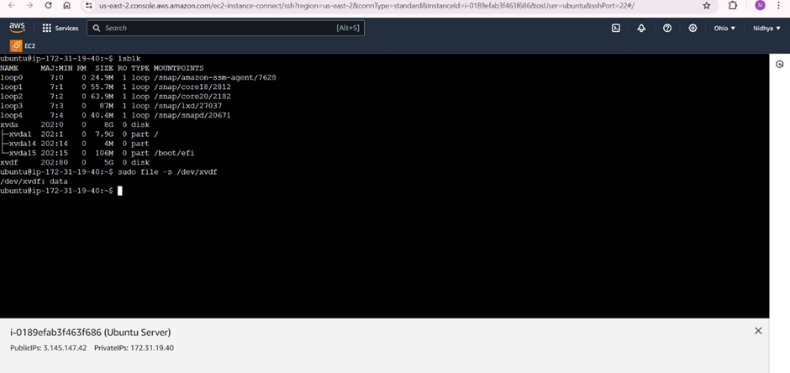

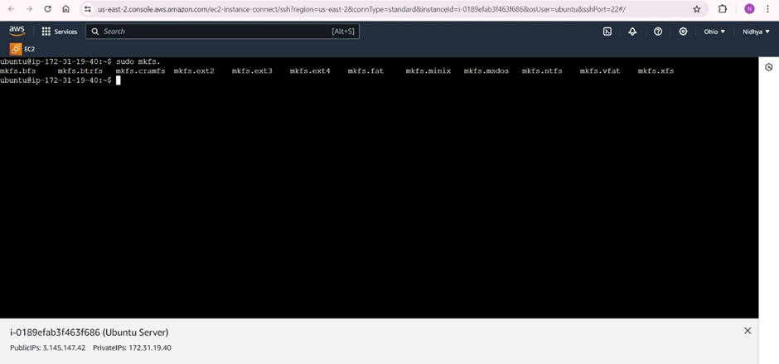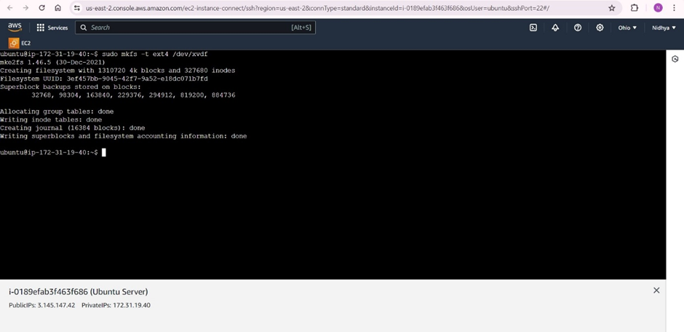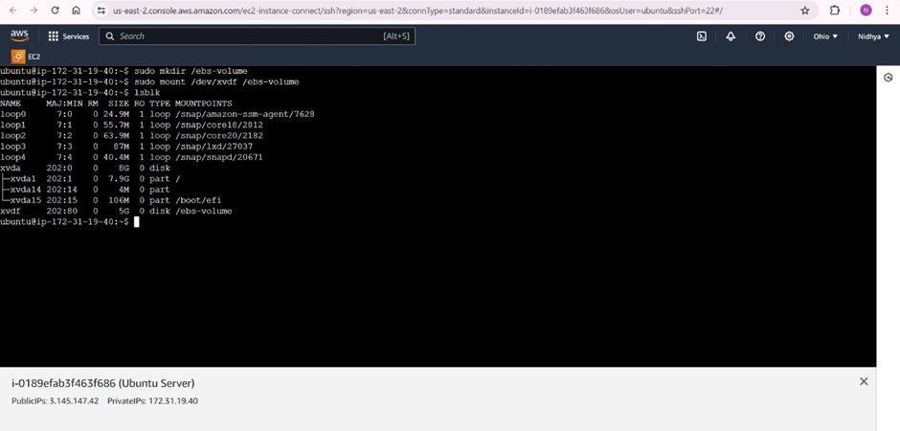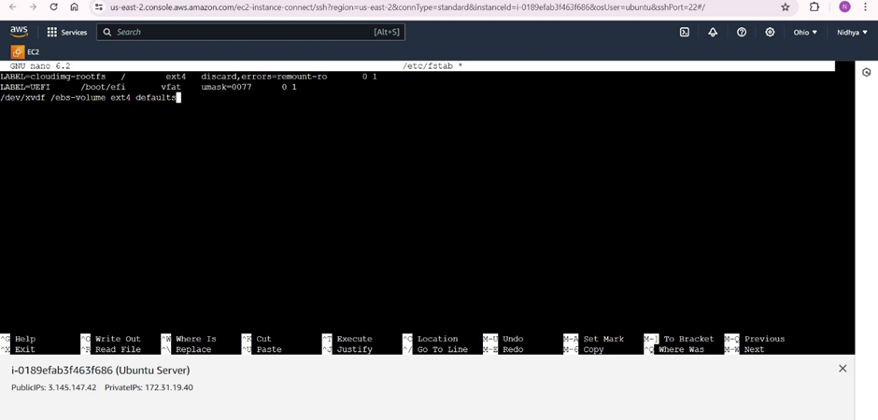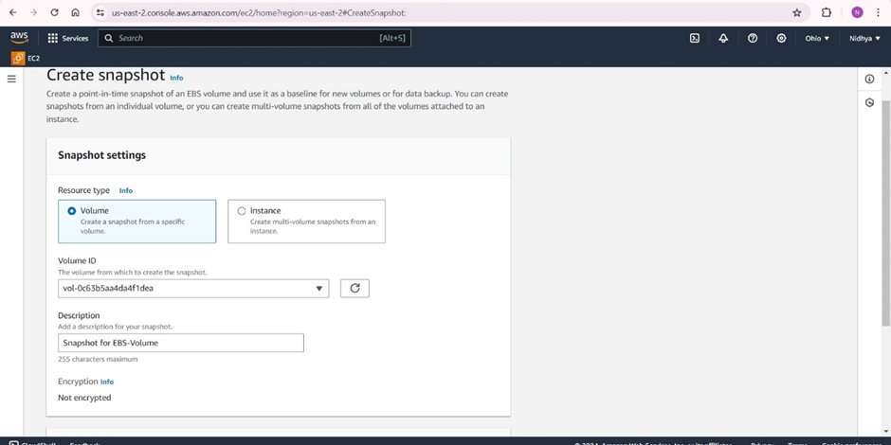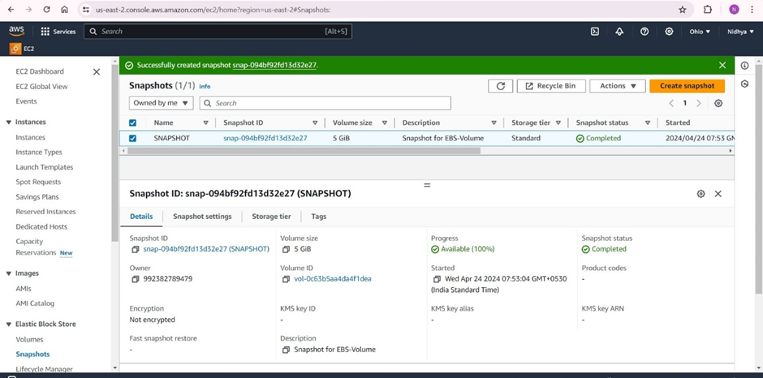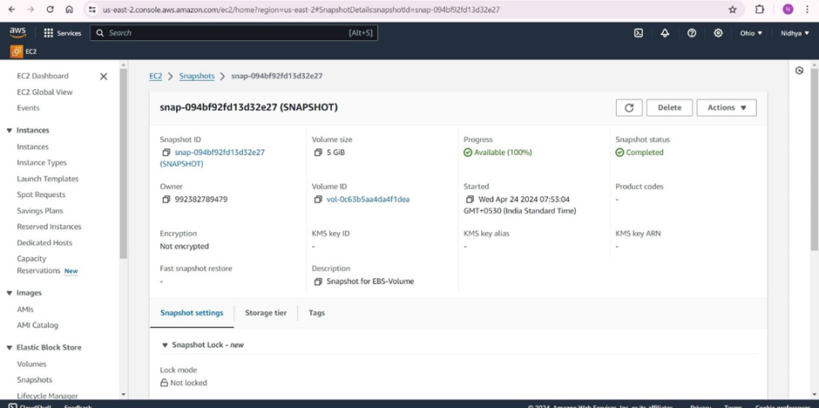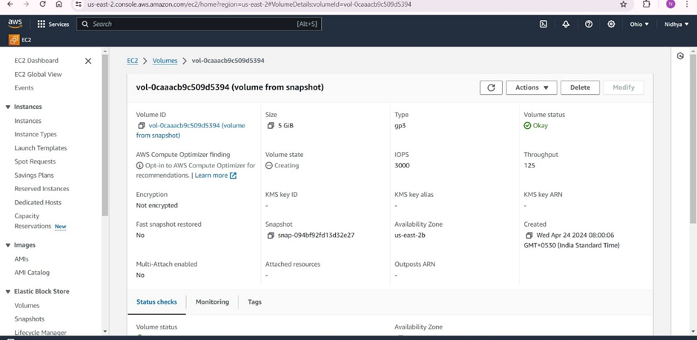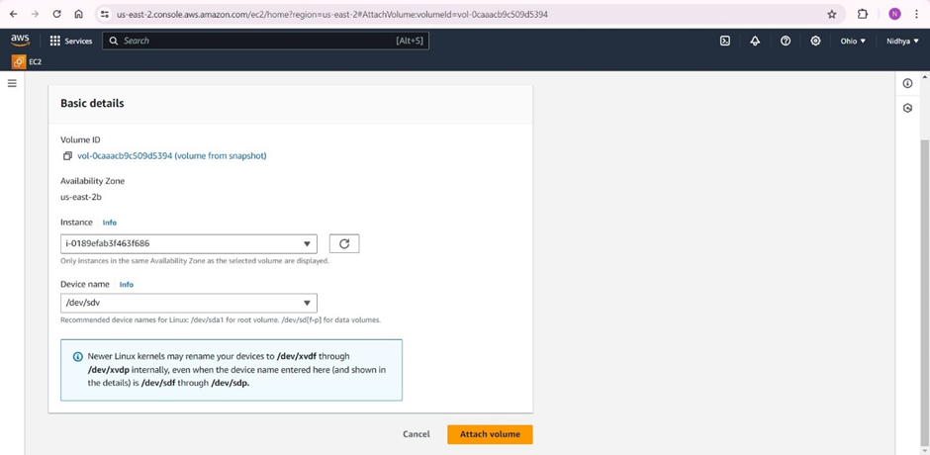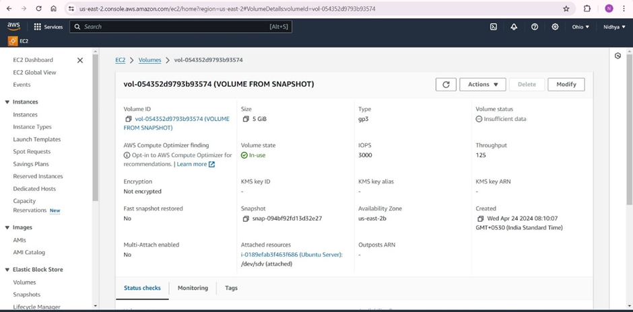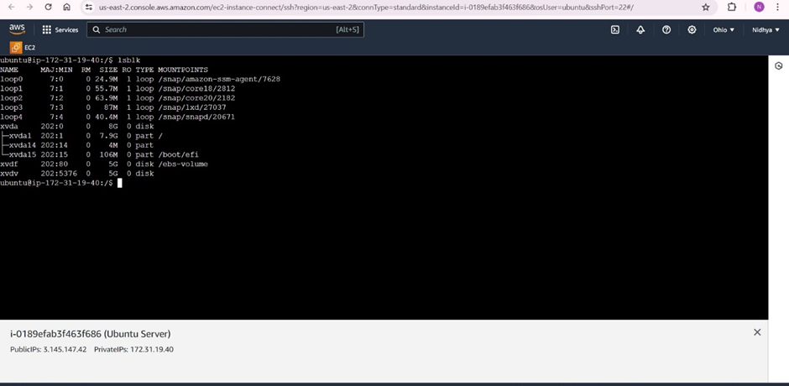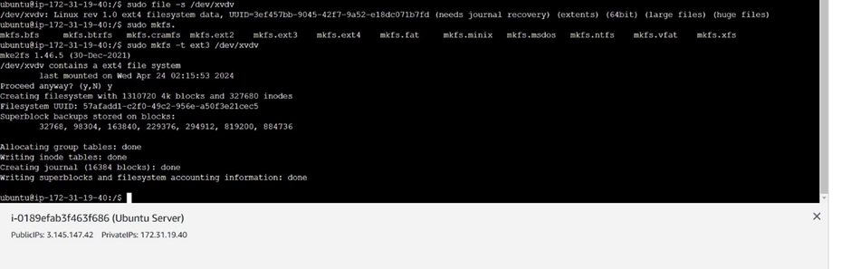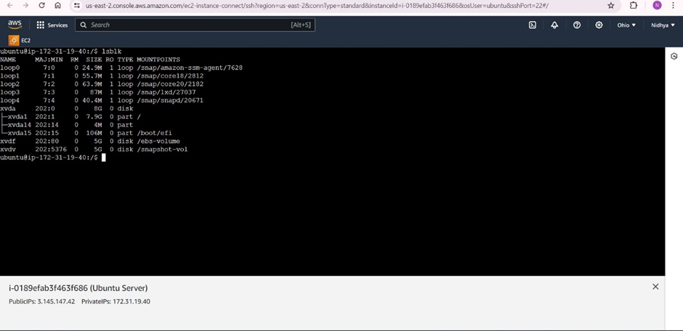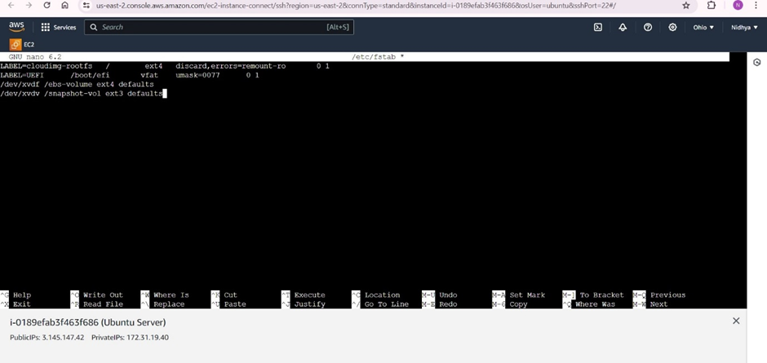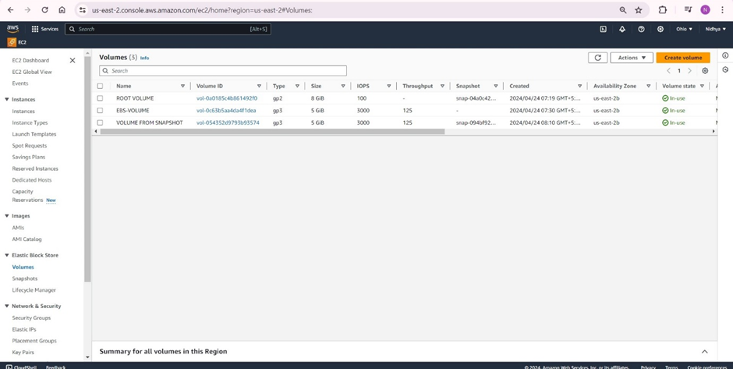

—-------------------------------------------------------------------------------------------------

Launch an EC2 instance -Windows along with a web server. Then, create an EBS volume of 5 GB, attach it to an EC2 machine Windows, and take a snapshot. Finally, create an EBS volume using the taken snapshot.

Apache Web Server running on Remote Windows machine:

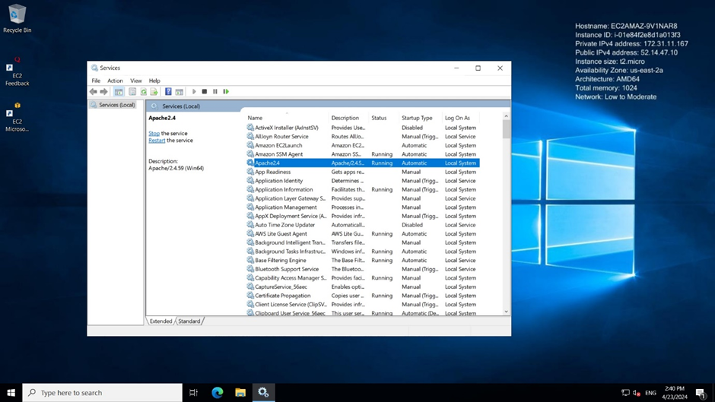

Output on Remote windows machine:

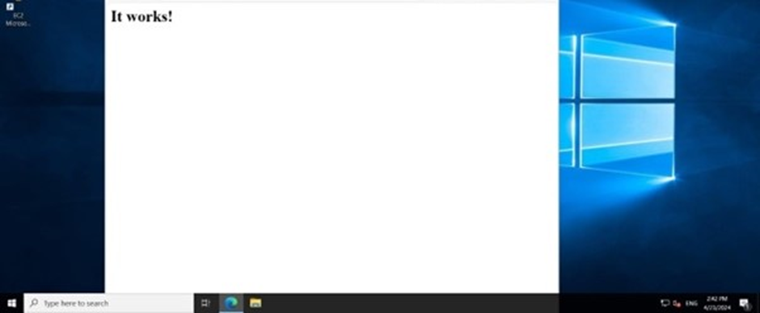

Creating volume of size 5 gb in EC2 instance:

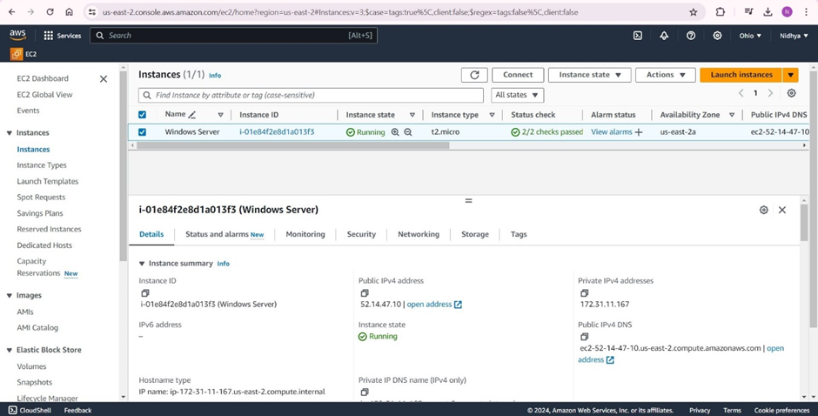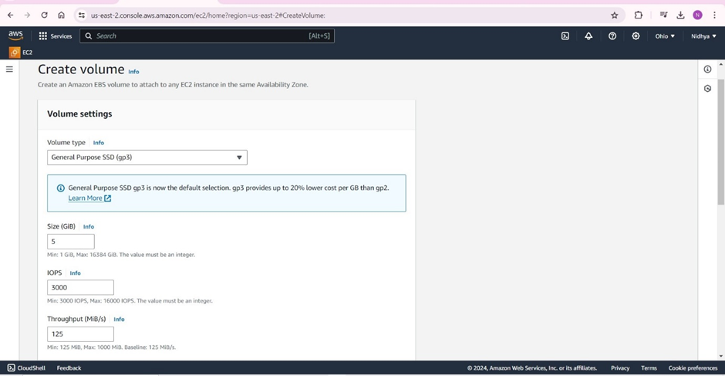

An Amazon EBS volume is a durable, block-level storage device that we can attach to our instances.

EBS volumes are flexible.

For current-generation volumes attached to current-generation instance types, we can dynamically increase size, modify the provisioned IOPS (Input Output Per Second) capacity.

IOPS is the standard measure of I/O operations per second on a storage device. It includes both read and write operations.

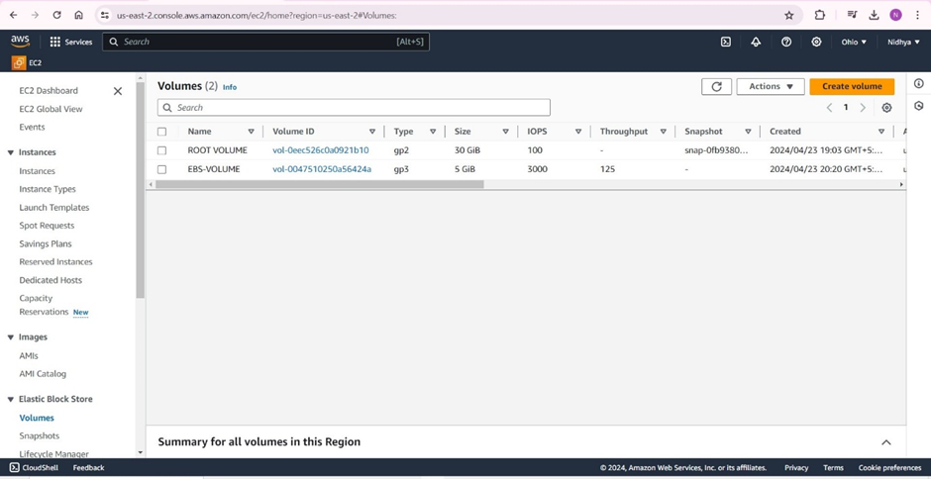

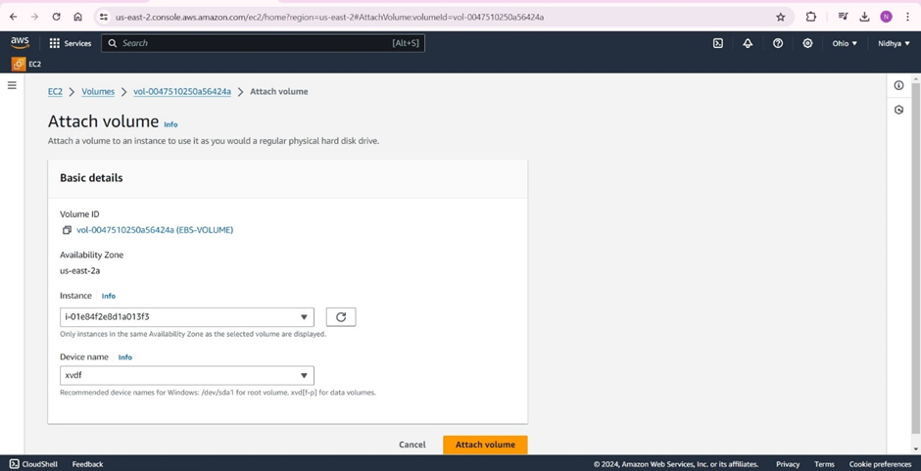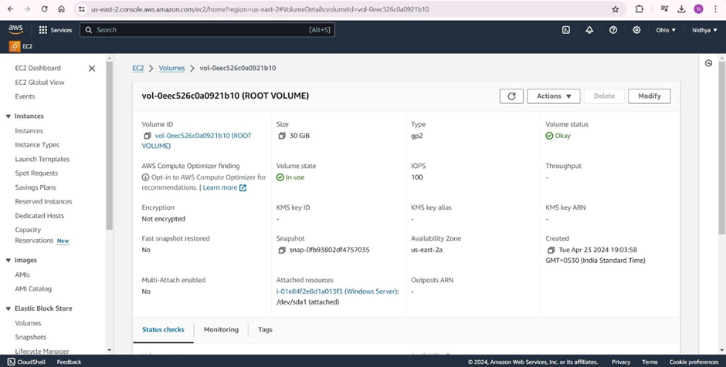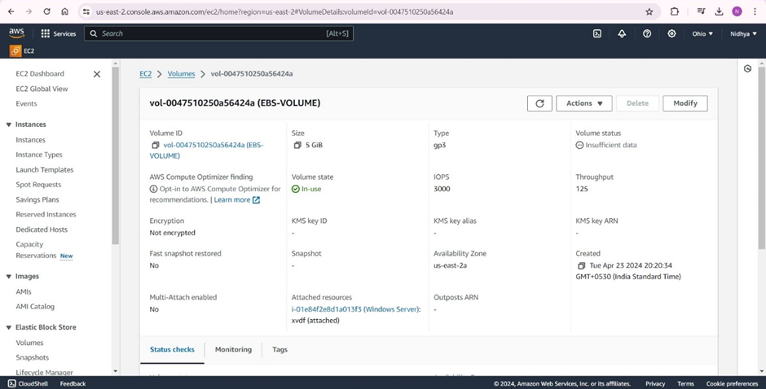Snapshots:

Amazon EBS provides the ability to create snapshots (backups) of any EBS volume and write a copy of the data in the volume to Amazon S3, where it is stored redundantly in multiple Availability Zones.

As we continue to write data to a volume, we can periodically create a snapshot of the volume to use as a baseline for new volumes.

These snapshots can be used to create multiple new EBS volumes or move volumes across Availability Zones.

Snapshots of encrypted EBS volumes are automatically encrypted.

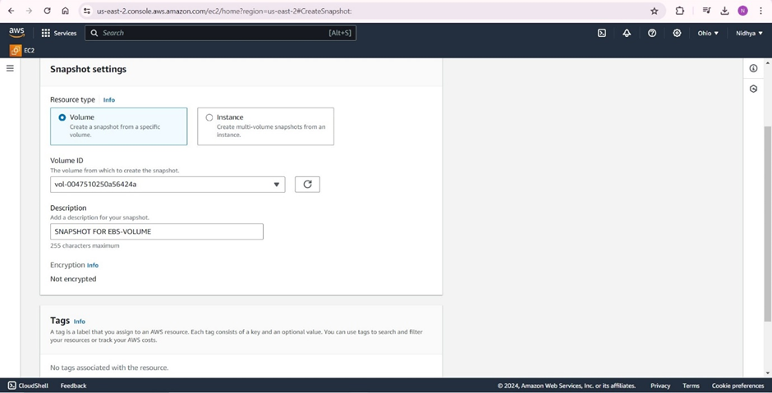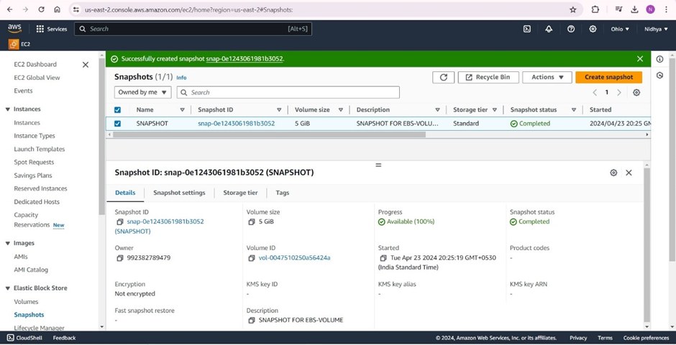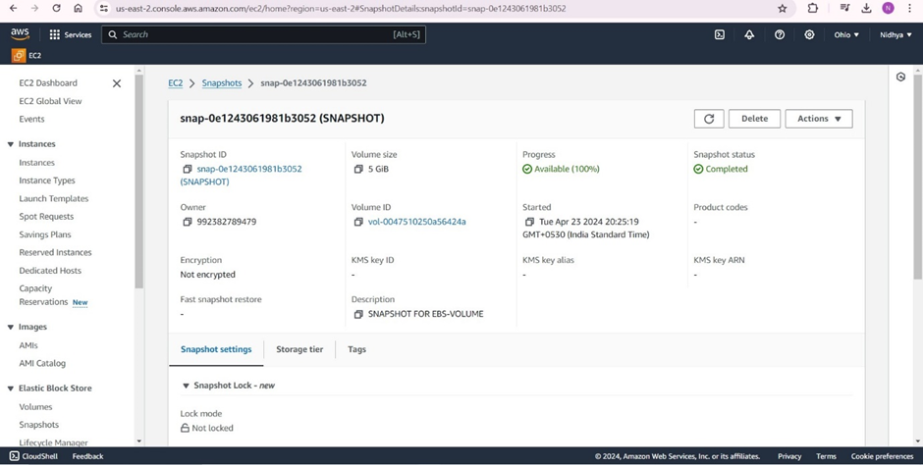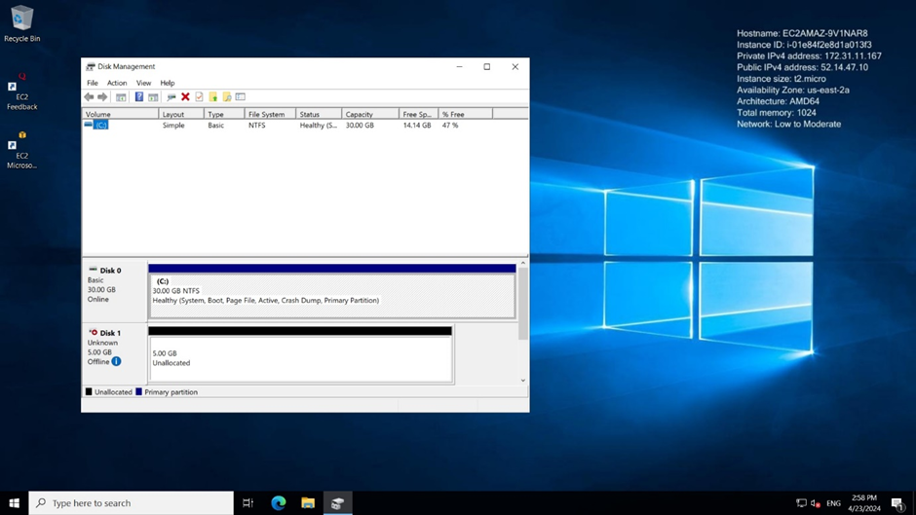

As we can see in the above screen the Volume is Unallocated, which means we are not able to use this volume, we need to make the volume disk online and format it by the filesystem.

We need to select your “Partition Style” MBR (Master Boot Record)

The Master Boot Record (MBR) is the information in the first sector of a hard disk.

It identifies how and where the system's operating system (OS) is located in order to be booted (loaded) into the computer's main storage or random access memory (RAM).

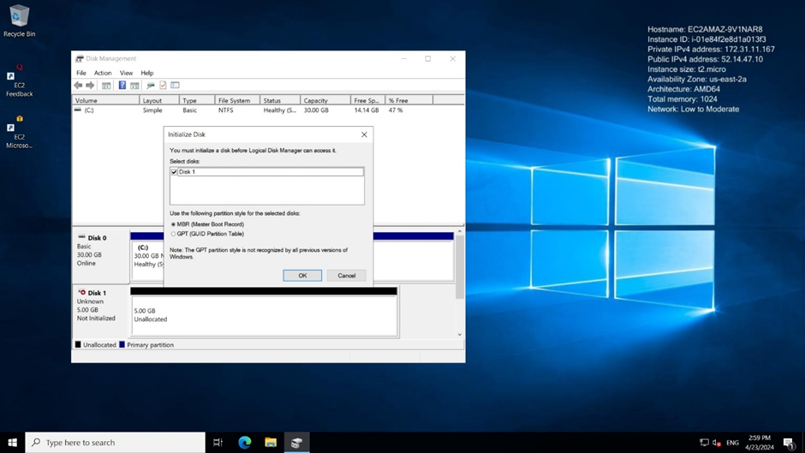

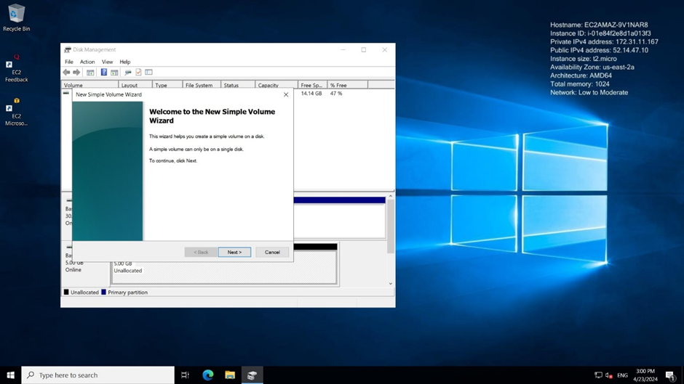

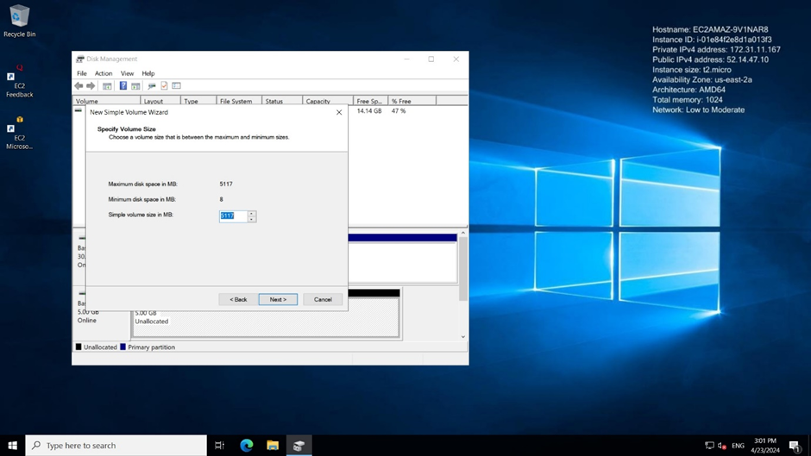

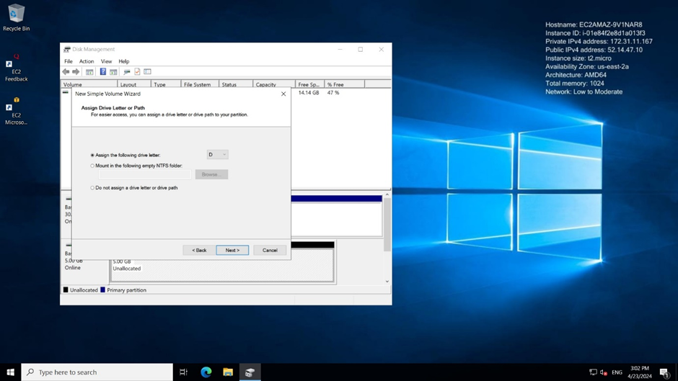

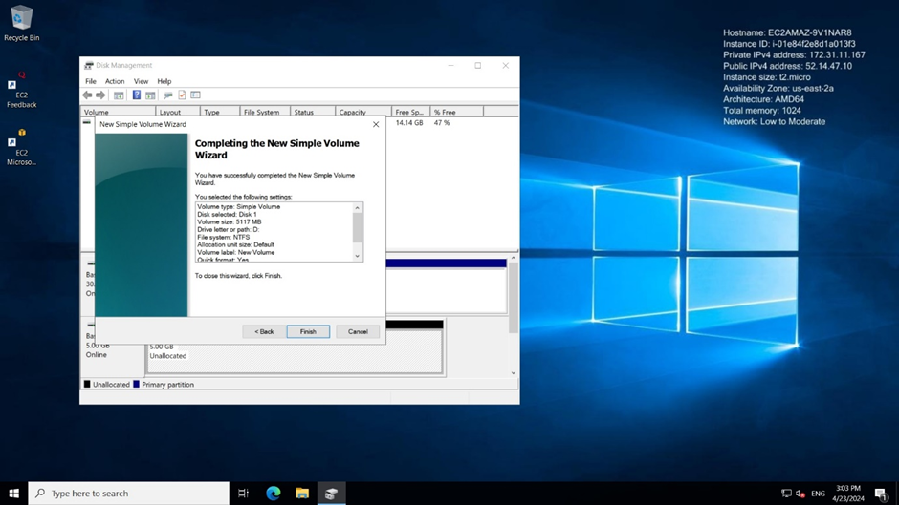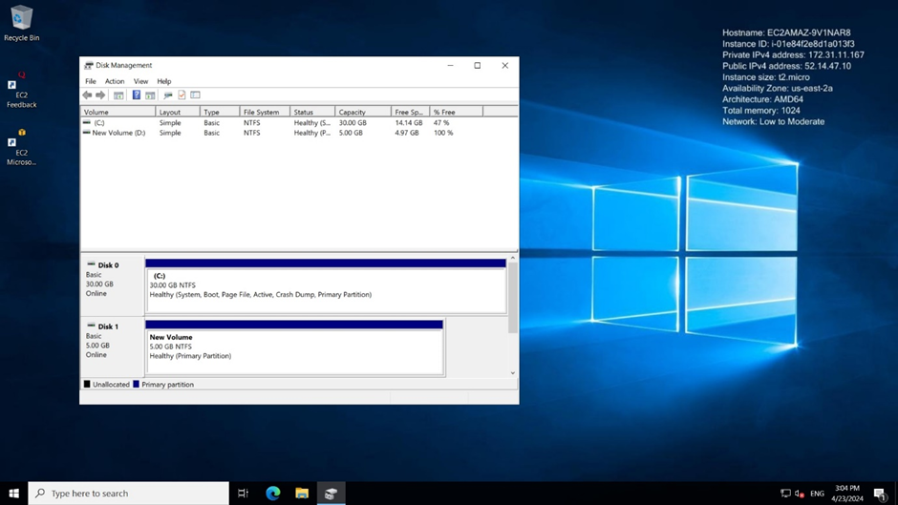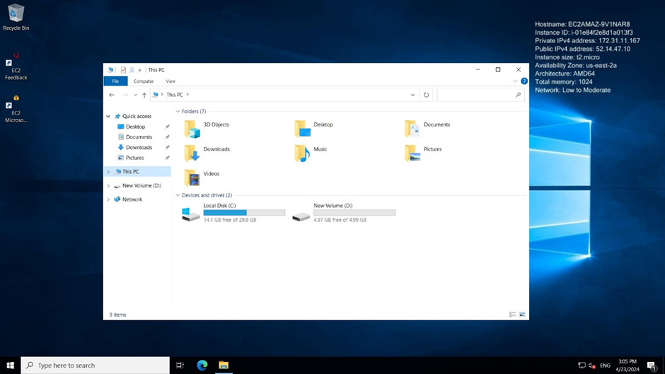

As we can see in the above image the Volume is attached and formatted successfully.

Finally, we can create an EBS volume using the taken snapshot.

Then we are able to attach EBS-volumes to the single or multiple instances.

